Doctrinal Mastery Verses - Old Testament Spring

Moses 1:39 | “This is my work and my glory—to bring to pass the immortality and eternal life of man.”
Moses 7:18 | “The Lord called his people Zion, because they were of one heart and one mind.”
Abraham 2:9-11 | The Lord promised Abraham that his seed would “bear this ministry and Priesthood unto all nations.”
Abraham 3:22-23 | As spirits we “were organized before the world was.
Genesis 1:26-27 | “God created man in his own image.”
Genesis 2:24 | “A man … shall cleave unto his wife: and they shall be one.”
Genesis 39:9 | “How then can I do this great wickedness, and sin against God?”
Exodus 20:3-17 | The Ten Commandments
Joshua 24:15 | “Choose you this day whom ye will serve.”
Psalm 24:3-4 | “Who shall stand in his holy place? He that hath clean hands, and a pure heart.”
Proverbs 3:5-6 | “Trust in the Lord with all thine heart … and he shall direct thy paths.”
Isaiah 1:18 | “Though your sins be as scarlet, they shall be as white as snow.”

Doctrinal Mastery Verses - Old Testament Spring

Moses 1:39 | “This is my work and my glory—to bring to pass the immortality and eternal life of man.”
Moses 7:18 | “The Lord called his people Zion, because they were of one heart and one mind.”
Abraham 2:9-11 | The Lord promised Abraham that his seed would “bear this ministry and Priesthood unto all nations.”
Abraham 3:22-23 | As spirits we “were organized before the world was.
Genesis 1:26-27 | “God created man in his own image.”
Genesis 2:24 | “A man … shall cleave unto his wife: and they shall be one.”
Genesis 39:9 | “How then can I do this great wickedness, and sin against God?”
Exodus 20:3-17 | The Ten Commandments
Joshua 24:15 | “Choose you this day whom ye will serve.”
Psalm 24:3-4 | “Who shall stand in his holy place? He that hath clean hands, and a pure heart.”
Proverbs 3:5-6 | “Trust in the Lord with all thine heart … and he shall direct thy paths.”
Isaiah 1:18 | “Though your sins be as scarlet, they shall be as white as snow.”
Doctrinal Mastery Verses - Old Testament Spring

Moses 1:39 | “This is my work and my glory—to bring to pass the immortality and eternal life of man.”
Moses 7:18 | “The Lord called his people Zion, because they were of one heart and one mind.”
Abraham 2:9-11 | The Lord promised Abraham that his seed would “bear this ministry and Priesthood unto all nations.”
Abraham 3:22-23 | As spirits we “were organized before the world was.
Genesis 1:26-27 | “God created man in his own image.”
Genesis 2:24 | “A man … shall cleave unto his wife: and they shall be one.”
Genesis 39:9 | “How then can I do this great wickedness, and sin against God?”
Exodus 20:3-17 | The Ten Commandments
Joshua 24:15 | “Choose you this day whom ye will serve.”
Psalm 24:3-4 | “Who shall stand in his holy place? He that hath clean hands, and a pure heart.”
Proverbs 3:5-6 | “Trust in the Lord with all thine heart … and he shall direct thy paths.”
Isaiah 1:18 | “Though your sins be as scarlet, they shall be as white as snow.”

Doctrinal Mastery Verses - Old Testament Spring

Moses 1:39 | “This is my work and my glory—to bring to pass the immortality and eternal life of man.”
Moses 7:18 | “The Lord called his people Zion, because they were of one heart and one mind.”
Abraham 2:9-11 | The Lord promised Abraham that his seed would “bear this ministry and Priesthood unto all nations.”
Abraham 3:22-23 | As spirits we “were organized before the world was.
Genesis 1:26-27 | “God created man in his own image.”
Genesis 2:24 | “A man … shall cleave unto his wife: and they shall be one.”
Genesis 39:9 | “How then can I do this great wickedness, and sin against God?”
Exodus 20:3-17 | The Ten Commandments
Joshua 24:15 | “Choose you this day whom ye will serve.”
Psalm 24:3-4 | “Who shall stand in his holy place? He that hath clean hands, and a pure heart.”
Proverbs 3:5-6 | “Trust in the Lord with all thine heart … and he shall direct thy paths.”
Isaiah 1:18 | “Though your sins be as scarlet, they shall be as white as snow.”
Doctrinal Mastery Verses - Old Testament Fall

Isaiah 5:20 | “Woe unto them that call evil good, and good evil.”
Isaiah 29:13-14 | The Restoration of the gospel is “a marvellous work and a wonder.”
Isaiah 53:3-5 | “Surely [Jesus Christ] hath borne our griefs, and carried our sorrows.”
Isaiah 58:6-7 | The blessings of a proper fast.
Isaiah 58:13-14 | “Turn away … from doing thy pleasure on my holy day; and call the sabbath a delight.”
Jeremiah 1:4-5 | “Before I formed thee in the belly… I ordained thee a prophet unto the nations.”
Ezekiel 3:16-17 | The prophet is “a watchman unto the house of Israel.”
Ezekiel 37:15-17 | The Bible and the Book of Mormon “shall become one in thine hand.”
Daniel 2:44-45 | God shall “set up a kingdom, which shall never be destroyed.
Amos 3:7 | “The Lord God … revealeth his secret unto his servants the prophets.”
Malachi 3:8-10 | The blessings of paying tithing.
Malachi 4:5-6 | Elijah “shall turn … the heart of the children to their fathers.”

Doctrinal Mastery Verses - Old Testament Fall

Isaiah 5:20 | “Woe unto them that call evil good, and good evil.”
Isaiah 29:13-14 | The Restoration of the gospel is “a marvellous work and a wonder.”
Isaiah 53:3-5 | “Surely [Jesus Christ] hath borne our griefs, and carried our sorrows.”
Isaiah 58:6-7 | The blessings of a proper fast.
Isaiah 58:13-14 | “Turn away … from doing thy pleasure on my holy day; and call the sabbath a delight.”
Jeremiah 1:4-5 | “Before I formed thee in the belly… I ordained thee a prophet unto the nations.”
Ezekiel 3:16-17 | The prophet is “a watchman unto the house of Israel.”
Ezekiel 37:15-17 | The Bible and the Book of Mormon “shall become one in thine hand.”
Daniel 2:44-45 | God shall “set up a kingdom, which shall never be destroyed.
Amos 3:7 | “The Lord God … revealeth his secret unto his servants the prophets.”
Malachi 3:8-10 | The blessings of paying tithing.
Malachi 4:5-6 | Elijah “shall turn … the heart of the children to their fathers.”
Doctrinal Mastery Verses - Old Testament Fall

Isaiah 5:20 | “Woe unto them that call evil good, and good evil.”
Isaiah 29:13-14 | The Restoration of the gospel is “a marvellous work and a wonder.”
Isaiah 53:3-5 | “Surely [Jesus Christ] hath borne our griefs, and carried our sorrows.”
Isaiah 58:6-7 | The blessings of a proper fast.
Isaiah 58:13-14 | “Turn away … from doing thy pleasure on my holy day; and call the sabbath a delight.”
Jeremiah 1:4-5 | “Before I formed thee in the belly… I ordained thee a prophet unto the nations.”
Ezekiel 3:16-17 | The prophet is “a watchman unto the house of Israel.”
Ezekiel 37:15-17 | The Bible and the Book of Mormon “shall become one in thine hand.”
Daniel 2:44-45 | God shall “set up a kingdom, which shall never be destroyed.
Amos 3:7 | “The Lord God … revealeth his secret unto his servants the prophets.”
Malachi 3:8-10 | The blessings of paying tithing.
Malachi 4:5-6 | Elijah “shall turn … the heart of the children to their fathers.”

Doctrinal Mastery Verses - Old Testament Fall

Isaiah 5:20 | “Woe unto them that call evil good, and good evil.”
Isaiah 29:13-14 | The Restoration of the gospel is “a marvellous work and a wonder.”
Isaiah 53:3-5 | “Surely [Jesus Christ] hath borne our griefs, and carried our sorrows.”
Isaiah 58:6-7 | The blessings of a proper fast.
Isaiah 58:13-14 | “Turn away … from doing thy pleasure on my holy day; and call the sabbath a delight.”
Jeremiah 1:4-5 | “Before I formed thee in the belly… I ordained thee a prophet unto the nations.”
Ezekiel 3:16-17 | The prophet is “a watchman unto the house of Israel.”
Ezekiel 37:15-17 | The Bible and the Book of Mormon “shall become one in thine hand.”
Daniel 2:44-45 | God shall “set up a kingdom, which shall never be destroyed.
Amos 3:7 | “The Lord God … revealeth his secret unto his servants the prophets.”
Malachi 3:8-10 | The blessings of paying tithing.
Malachi 4:5-6 | Elijah “shall turn … the heart of the children to their fathers.”

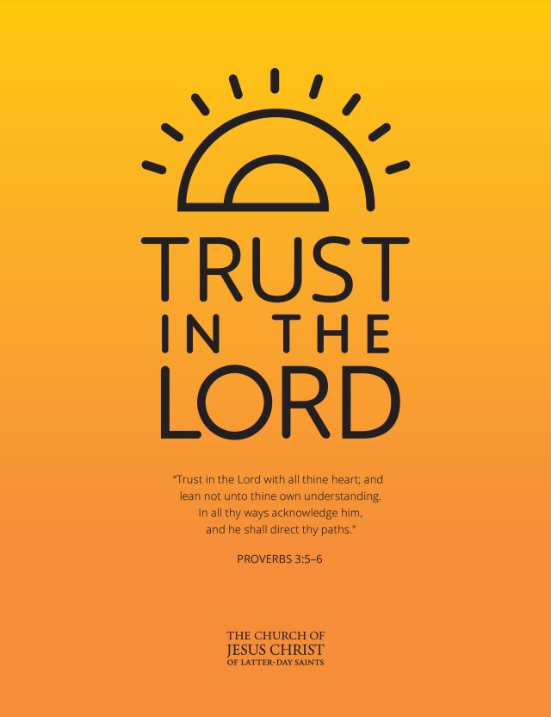

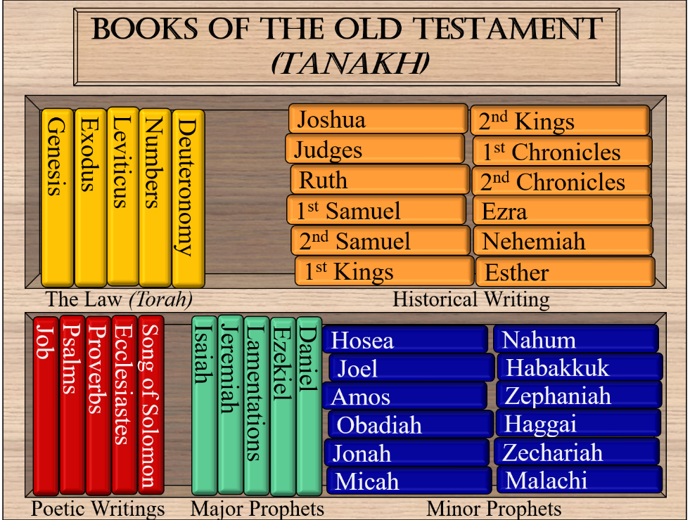

Doctrinal Mastery Verses – New Testament Spring

Matthew 5:14-16 | “Let your light so shine before men.”
Matthew 11:28-30 | “Come unto me, all ye that labor and are heavy laden, and I will give you rest.”
Matthew 16:15-19 | Jesus said, “I will give unto thee the keys of the kingdom.”
Matthew 22:36-39 | “Thou shalt love the Lord thy God… Thou shalt love thy neighbour.”
Luke 2:10-12 | “For unto you is born this day in the city of David a Saviour, which is Christ the Lord.”
Luke 22:19-20 | Jesus Christ commanded, partake of the sacrament “in remembrance of me.”
Luke 24:36-39 | “For a spirit hath not flesh and bones, as ye see me have.”
John 3:5 | “Except a man be born of water and of the Spirit, he cannot enter into the kingdom of God.”
John 3:16 | “For God so loved the world, that he gave his only begotten Son.”
John 7:17 | “If any man will do his will, he shall know of the doctrine.”
John 17:3 | “And this is life eternal, that they might know thee the only true God, and Jesus Christ.”
1 Corinthians 6:19-20 | “Your body is the temple of the Holy Ghost.”

Doctrinal Mastery Verses – New Testament Spring

Matthew 5:14-16 | “Let your light so shine before men.”
Matthew 11:28-30 | “Come unto me, all ye that labor and are heavy laden, and I will give you rest.”
Matthew 16:15-19 | Jesus said, “I will give unto thee the keys of the kingdom.”
Matthew 22:36-39 | “Thou shalt love the Lord thy God… Thou shalt love thy neighbour.”
Luke 2:10-12 | “For unto you is born this day in the city of David a Saviour, which is Christ the Lord.”
Luke 22:19-20 | Jesus Christ commanded, partake of the sacrament “in remembrance of me.”
Luke 24:36-39 | “For a spirit hath not flesh and bones, as ye see me have.”
John 3:5 | “Except a man be born of water and of the Spirit, he cannot enter into the kingdom of God.”
John 3:16 | “For God so loved the world, that he gave his only begotten Son.”
John 7:17 | “If any man will do his will, he shall know of the doctrine.”
John 17:3 | “And this is life eternal, that they might know thee the only true God, and Jesus Christ.”
1 Corinthians 6:19-20 | “Your body is the temple of the Holy Ghost.”
Doctrinal Mastery Verses – New Testament Spring

Matthew 5:14-16 | “Let your light so shine before men.”
Matthew 11:28-30 | “Come unto me, all ye that labor and are heavy laden, and I will give you rest.”
Matthew 16:15-19 | Jesus said, “I will give unto thee the keys of the kingdom.”
Matthew 22:36-39 | “Thou shalt love the Lord thy God… Thou shalt love thy neighbour.”
Luke 2:10-12 | “For unto you is born this day in the city of David a Saviour, which is Christ the Lord.”
Luke 22:19-20 | Jesus Christ commanded, partake of the sacrament “in remembrance of me.”
Luke 24:36-39 | “For a spirit hath not flesh and bones, as ye see me have.”
John 3:5 | “Except a man be born of water and of the Spirit, he cannot enter into the kingdom of God.”
John 3:16 | “For God so loved the world, that he gave his only begotten Son.”
John 7:17 | “If any man will do his will, he shall know of the doctrine.”
John 17:3 | “And this is life eternal, that they might know thee the only true God, and Jesus Christ.”
1 Corinthians 6:19-20 | “Your body is the temple of the Holy Ghost.”

Doctrinal Mastery Verses – New Testament Spring

Matthew 5:14-16 | “Let your light so shine before men.”
Matthew 11:28-30 | “Come unto me, all ye that labor and are heavy laden, and I will give you rest.”
Matthew 16:15-19 | Jesus said, “I will give unto thee the keys of the kingdom.”
Matthew 22:36-39 | “Thou shalt love the Lord thy God… Thou shalt love thy neighbour.”
Luke 2:10-12 | “For unto you is born this day in the city of David a Saviour, which is Christ the Lord.”
Luke 22:19-20 | Jesus Christ commanded, partake of the sacrament “in remembrance of me.”
Luke 24:36-39 | “For a spirit hath not flesh and bones, as ye see me have.”
John 3:5 | “Except a man be born of water and of the Spirit, he cannot enter into the kingdom of God.”
John 3:16 | “For God so loved the world, that he gave his only begotten Son.”
John 7:17 | “If any man will do his will, he shall know of the doctrine.”
John 17:3 | “And this is life eternal, that they might know thee the only true God, and Jesus Christ.”
1 Corinthians 6:19-20 | “Your body is the temple of the Holy Ghost.”

